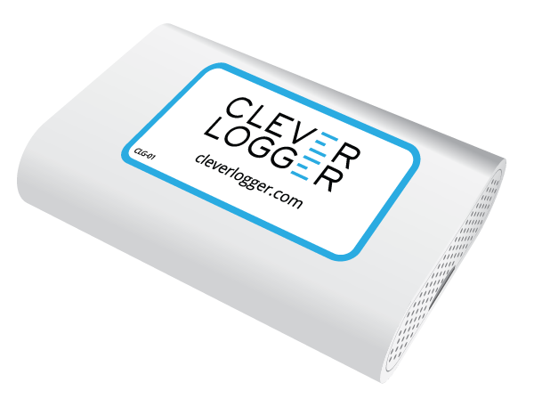

Clever Logger Procedures

July 2020

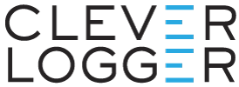

Who should use this guide?
This guide is aimed at daily Clever Logger users.
It does not describe how to set up and configure Clever Logger. For that you want the Clever Logger Configuration Guide (cleverlogger.com/guide).
This guide will show users:
- How to log in to the Clever Logger dashboard,
- How to read your data, and
- What to do if you get an alarm notification

If you have any questions about how to use your Clever Logger, call us on 1300 80 88 89.

How to log in to the Clever Logger Dashboard
Go to https://cloud.cleverlogger.com
If you have logged in before, you will automatically be taken to the dashboard.
If not, enter your email address to receive a Sign In code in your inbox. Enter the Sign In code to sign into the dashboard.

Saving the Dashboard to your bookmarks
In most Windows browsers, pressing Ctrl-D while you’re on the dashboard page will add the dashboard to your bookmarks. On Macs, it is generally Command-D.
This will allow you to quickly open the dashboard whenever you need to.

Reading your data
To see what’s happing at your Locations, go to the dashboard and choose Locations from the blue left-hand menu.
You will see a list of your Locations.
The coloured line on the left of the panel is the Status Indicator Line.
If everything is OK, the line will be GREEN.
If the line is ORANGE or RED, the location has an alarm. Learn how to deal with alarms in the next section.

View the graph
Click on the View button to see the Location’s data.
Clicking on the Options button in the top right corner of the graph will open the graph’s Display Options panel.
The most common thing you will adjust on the panel is the Date Range for the graph.
Choose from the list of preset date ranges or select Custom to set your own start and end dates.
Click the Save Changes button to apply your date range to the graph.

Zooming in on the graph
You can also zoom in a particular section of the graph by zooming in.
- Click and hold the left mouse button
- Drag from left to right
- Release the mouse button
The graph will adjust to show your new selection.
To zoom back out, click on the Reset Zoom button.

Printing out a report
To create a report on a particular date range, choose Reports from the main menu on the left.
Click on the Add a Report button in the top left corner of the screen.
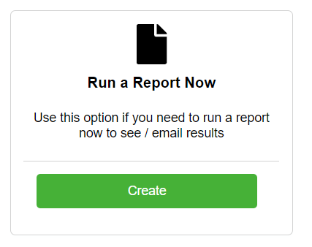
In the Run a Report Now section, click on the Create button.
Choose one of the Preset reports or choose a Custom report.

Report Types
Min/Max - Gives the minimum and maximum temperatures. For daily reports, you will see an hourly min/max. For reports that span multiple days, you will get a daily min/max.
Min/Max + Extremes (most popular) - This is just like the Min/Max report but if there has been a breach, it will show a complete record of the out-of-range temperatures.
All Readings - As it sounds - a complete record of all readings.
Locations
Choose which location to include.
File Type
If you chose a Min/Max report, we recommend a PDF report.
If you chose All Readings, we recommend an Excel report.
Report Name
Give your report a name. Today’s date will be automatically added to whatever name you choose.
e.g. If you called your report My Report, the file would be My Report_20200601.pdf
Date Range
Click on a date to select the starting date for your report. Click again to select the end date.
If you just want a single day report, click twice on the same day.

Timezone
Unless you are printing a report for a Location in a different timezone, just leave this as default.
Recipients
If you would like to email the report to yourself or another user, select recipients here. This is optional.
Download to Finish
Click the Download button to download the report to your computer.

What to do if you get an alarm notification
Depending on your settings, you will receive an email or a phone app message or both when an alarm condition occurs.
It is important that you do not ignore alarms.

Acknowledge the alarm
Open the Clever Logger dashboard and locate the alarm.
If the alarm condition is still active (e.g. in the example above, the temperature in the “Faulty Fridge” is too high), the status indicator line will be RED.
Depending on your settings, you will probably have received an initial notification, possibly followed by some reminders. To stop the reminders, you will want to acknowledge the alarm on the dashboard. Open the alarm and click on the Acknowledge button.
In this situation, your next thought should be to investigate and rectify the cause of the alarm.

Close the alarm
Once the alarm condition has ended, the status indicator line will change to ORANGE.
At this time, if you haven’t already acknowledged the alarm, you can do that. This will also close the alarm. If you had previously acknowledged the alarm, you can now close it.
Either way, the status indicator line will turn GREEN.

It should be your goal to have all your status indicators GREEN at all times.

If you have any questions about using your Clever Logger, go to cleverlogger.com and check out the How To section. It is constantly being updated with information and videos.

